
PROJECT:-
Housing PROJECT

author:-
ATUL DAHIMA

PROBLEM STATEment:-
Houses are one of the necessary need of each and every person around the globe and therefore housing and real estate market is one of the markets which is one of the major contributors in the world’s economy. It is a very large market and there are various companies working in the domain. Data science comes as a very important tool to solve problems in the domain to help the companies increase their overall revenue, profits, improving their marketing strategies and focusing on changing trends in house sales and purchases. Predictive modelling, Market mix modelling, recommendation systems are some of the machine learning techniques used for achieving the business goals for housing companies. Our problem is related to one such housing company. A US-based housing company named Surprise Housing has decided to enter the Australian market. The company uses data analytics to purchase houses at a price below their actual values and flip them at a higher price. For the same purpose, the company has collected a data set from the sale of houses in Australia. The data is provided in the CSV file below.
The company is looking at prospective properties to buy houses to enter the market. You are required to build a model using Machine Learning in order to predict the actual value of the prospective properties and decide whether to invest in them or not. For this company wants to know:
• Which variables are important to predict the price of variable?
• How do these variables describe the price of the house?
Business Goal:
You are required to model the price of houses with the available independent variables. This model will then be used by the management to understand how exactly the prices vary with the variables. They can accordingly manipulate the strategy of the firm and concentrate on areas that will yield high returns. Further, the model will be a good way for the management to understand the pricing dynamics of a new market.

Importing libraries and load data:-
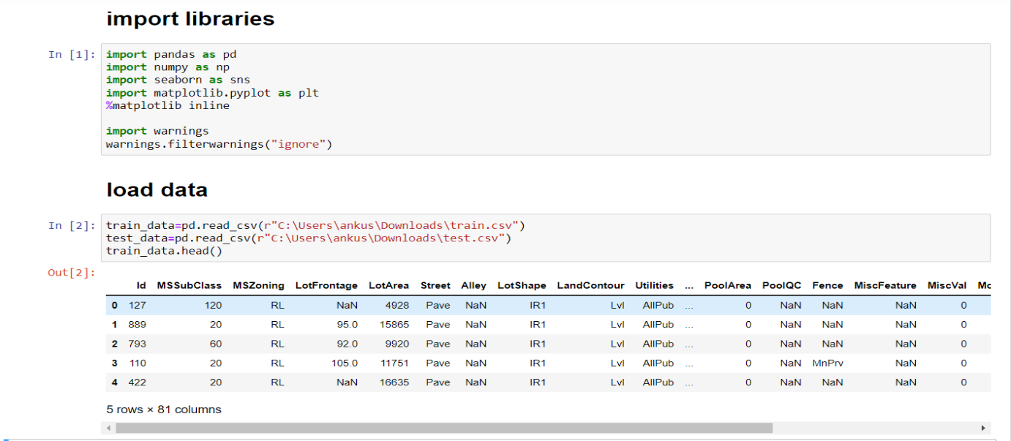
There are two data set one is train and other is test dataset . We have to make prediction on the test dataset using train dataset
Few libraries are used initially for different purpose like:-
- Numpy:- for mathematical operation
- Pandas:- for data preprocessing
- Matplotlib and Seaborn:- for data visualization
- Warnings:- for some warnings

As most of the columns are non numerical so we will do label encoding first

LABEL ENCODING:-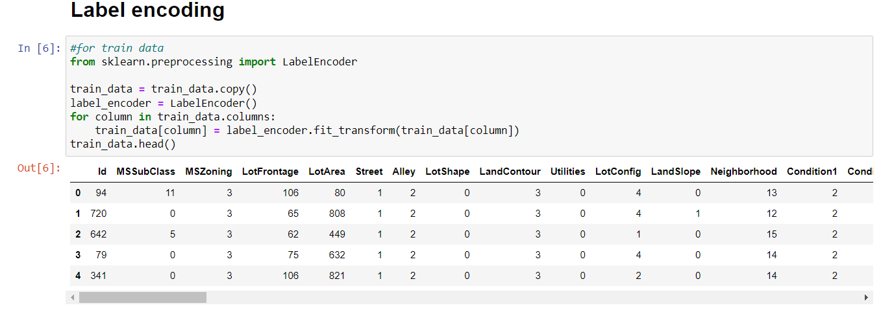
Now we can clearly see that after doing label encoding all the columns have changed into numerical column. Same as we have to do with test data also.

CHECK FOR NULL VALUES AND DATA DESCRIPTION :-
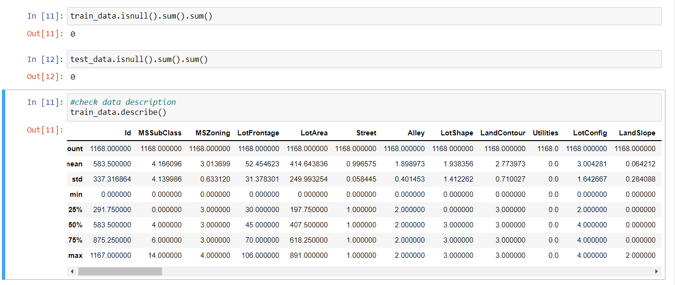

data.isnull().sum() shows that there is no null values in the data .
While data description shows some calculation about the data like:-mean,median,mode,std and some other calculation_
On the top of the data description we can see that all the columns have same value which also defines that there is no null value

Seperating labels and features:-
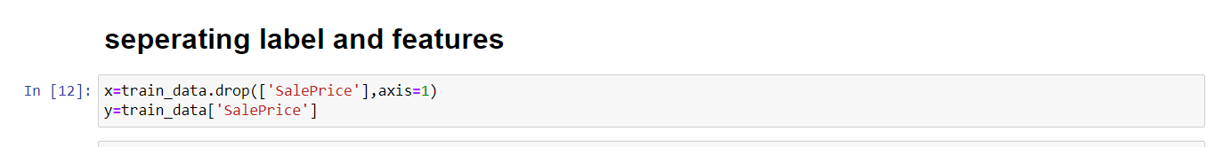
Above we have separate the data set into label and features. As we have to predict the sales price of houses so sales price is the target vriable.

Correlation:-
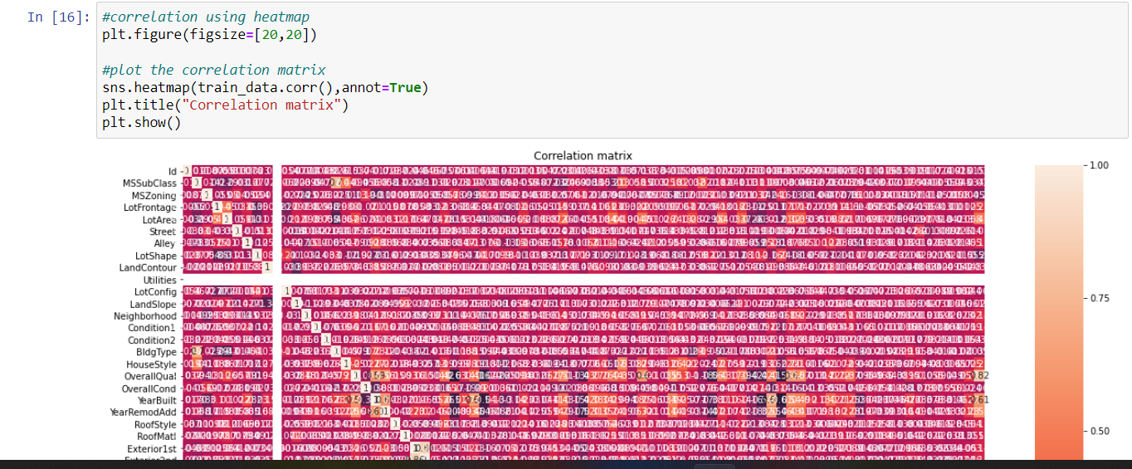

Above diagram shows the correlation among all the columns.
As here are so much column so we cannot easily identify the correlation among all the columns so lets print the correlation table.
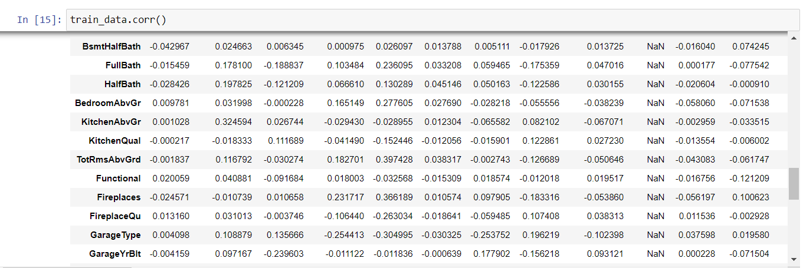
Using abobe table we can easily identify the correlation among all the columns.

Data distribution:-
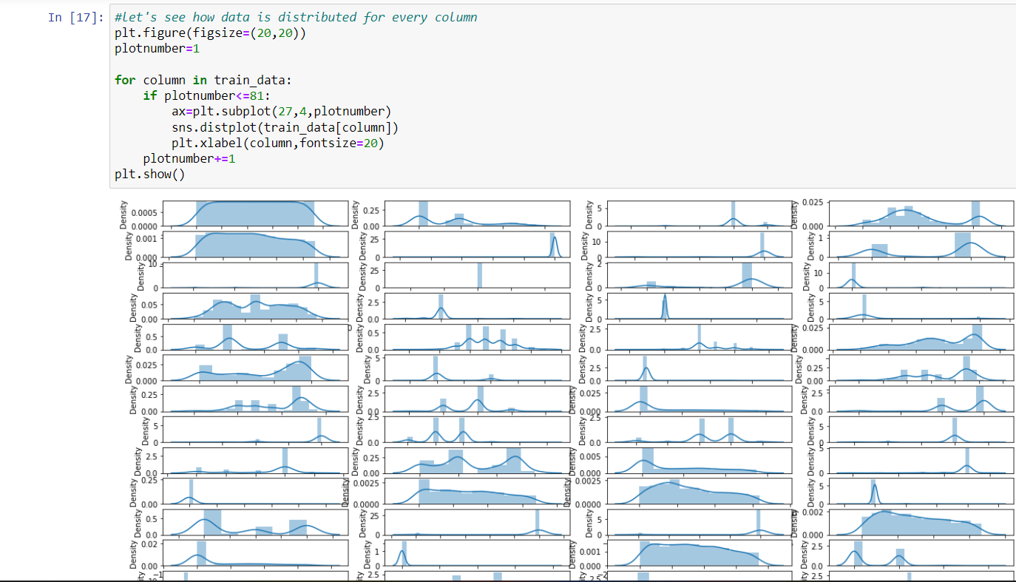
Above code shows the data distribution among all the columns , the data distribution is looking not so good , let go ahead with checking skewness in the data distribution.

Skewness:-
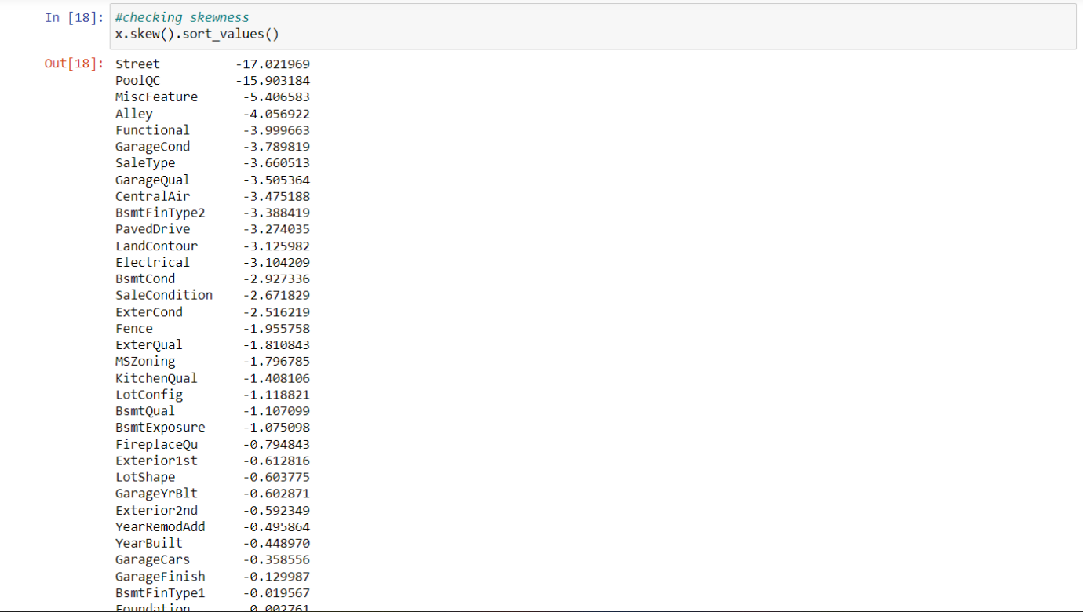
As we can see that lots of column are highly skeweed so we will try some method for handle the skewness of the data
Here we use the np.sqrt() method for handling the skewness of the data.

DATA SCALING:-

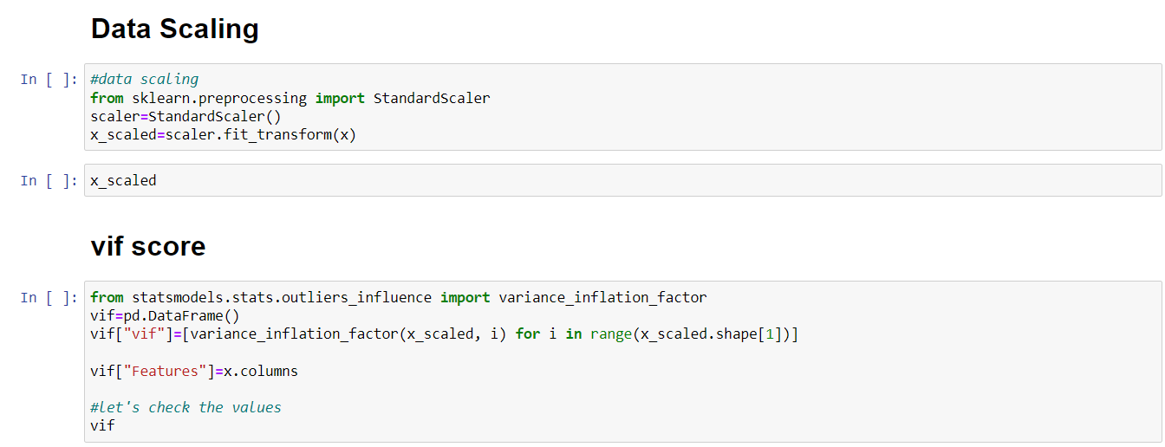

Scaled the features variables and then check the vif score for scaled data to check the multicollinearity using “variance_inflation_factor”

Training process:-
Here we will use Linear Regression model for model training and testing
Start the training process and some important module for model training and then split the data in training and testing data set

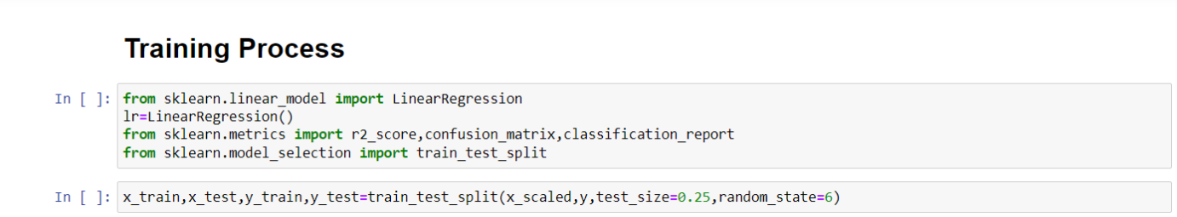
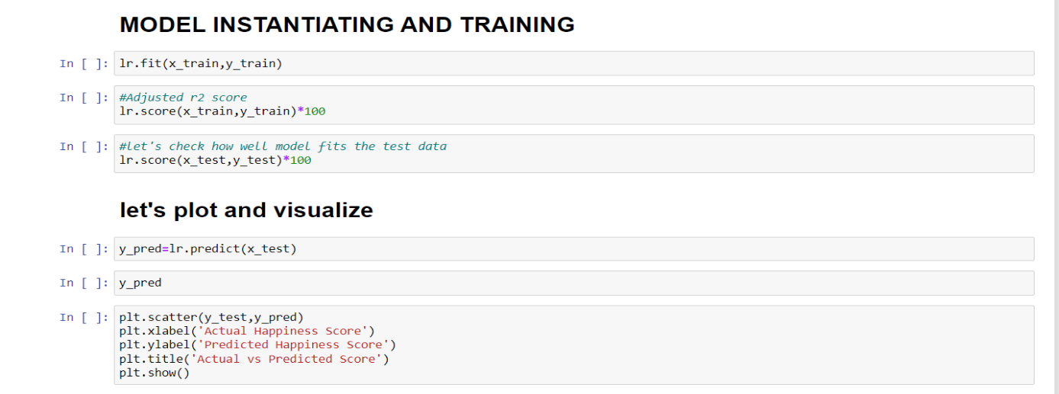

Check r2 score for training and testing data and then plot the graph for actual and predicted result with scatter plot
After this do cross validation and hyper parameter tunning for the model
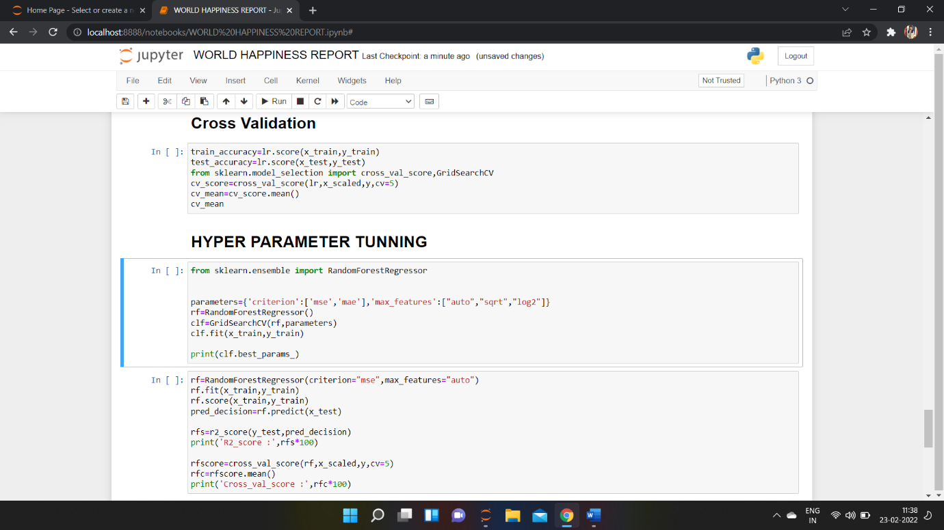
Here we did the cross validation of the model and after do the hyper parameter tunning of the model.

We get the final accuracy of the model as 89%.

SAVE MODEL:-
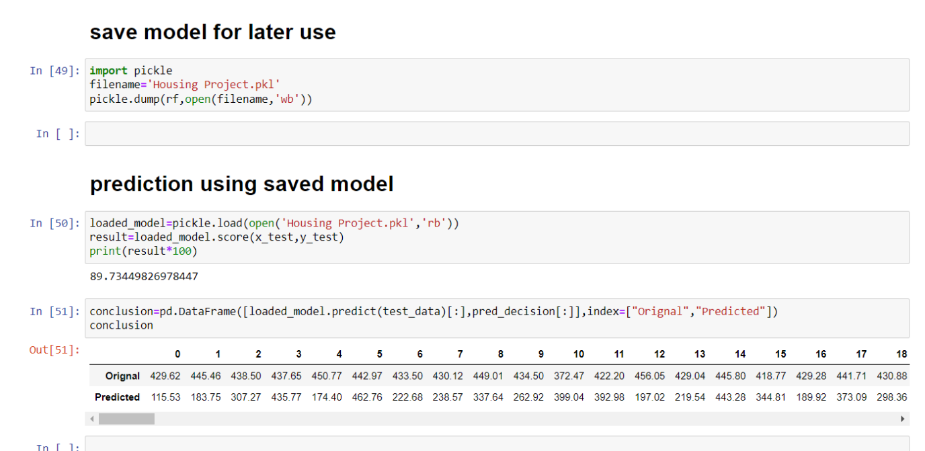

Save the model for late use to prediction.

SUMMARY:-
We started with the data exploration where we got a feeling for the dataset, checked about missing data and learned which features are important. During this process we used seaborn and matplotlib to do the visualizations. During the data pre-processing part.
Afterwards we started training model using Linear Regression and applied cross validation on it. Then we do the Hyper Parameter tunning of the model and get the final accuracy score for the model.
Later we save the model for later use for prediction.

